Supplementary Simulations

Further simulation has been performed since the CFP report was submitted. These simulations were only used to get a general idea of the range of motion for each prototype; no optimization has been performed on the geometry of any of the prototypes. The lengths and angles used were similar to the lengths and angles on the prototype from last year.

Prototype 3:

Prototype 3 utilized a linear sliding link in the radial direction. This prototype was examined using 2 different setups, PT3a and PT3b.

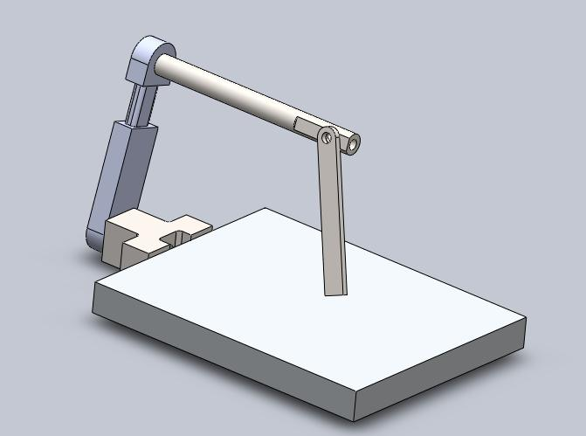

PT3a allowed link 1 to rotate while link 3 was not allowed to rotate with respect to link 1. This configuration yielded results similar to PT1.

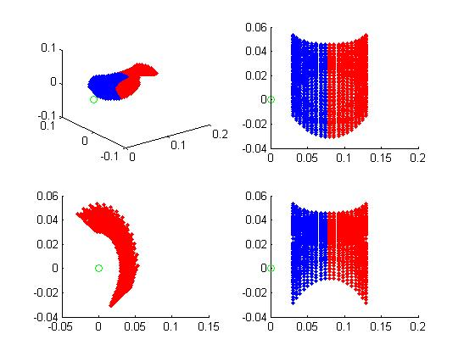

PT3b did not allow link 1 to rotate while link 3 was free to rotate with respect to link 1. These results appear to give the largest range of motion.

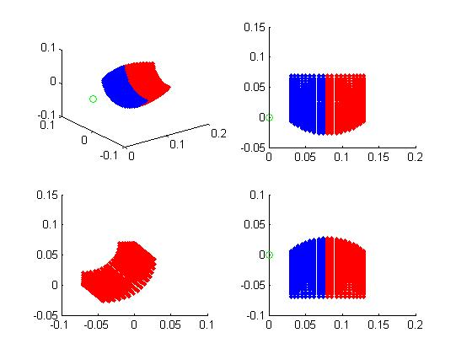

Prototype 4:

This prototype was suggested by Tony and increased the complexity of link 2 in order to eliminate link 3. Link 4 was moved up in order to have the effective angle between links 1 and 2 as far away from any singularities as possible. 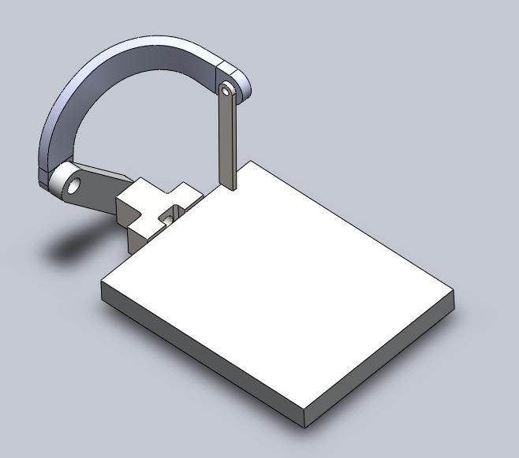

The simulated range of motion for this prototype was somewhat surprising. The area this prototype covers in the yz-plane is a very pointed arc. Further simulation could be run in the future to see if modifying geometric parameters could yield a more favourable range of motion.

